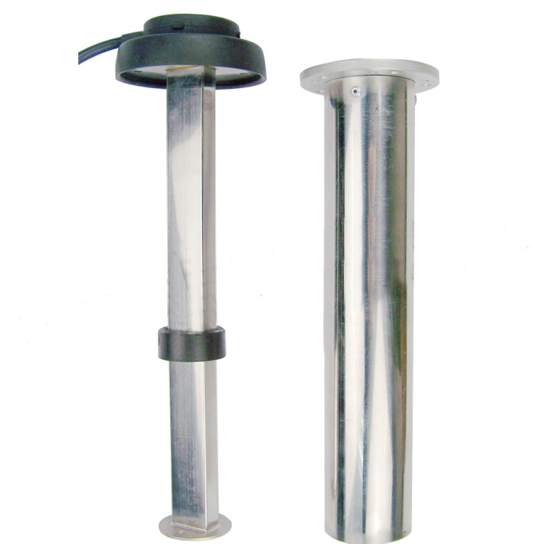F8 series fuel level sensor

Place of Origin: China

Brand Name: JYM

Model: F8

Certificate: CE

Minimum Order Quantity: 1pcs

Payment Term: T/T, Western Union, L/C

Delivery Time: 15 days after payment

Functions/Features:

-Applicable to: various vessel fuel tanks, vehicle fuel tanks, generator sets, especially to GPS service and fleet.

-Simple structure, simple installation: mounted flange, international standard SAE 5 holes or SAE 6 holes screw installation

-Wide range of input voltage: ranging from 9V to 36V, adaptable to miscellaneous environment

-Protection against overload, short circuit and reverse connection

-Multiple signal output: Voltage output 0~5V, Current output: 4~20mA, Resistance output: 0~190Ω

Specifications:

|  |  |
| --- | --- |
| Principle of signal acquisition | Float moving |
| Feeding (input powder) | 9~36V |
| Accuracy | <1% |
| Signal format/ output format (Optional) | Option A: voltage 0~5V  Option B: current 4~20mA  Option C: Resistance 0~190Ω |
| Communication interface | RS232 or TX485 |
| Measurement range | 100mm~2000mm |
| Housing material | SUS304/316 stainless steel |
| working temperature | -40℃~+85℃ (-40℉~+185℉) |
| Lifespan/service | 5 million times |
| Installation | SAE 5 holes or SAE 6 holes  BSP screw or NPT screw |
| Weight | 400g |